***Laporan 4***

**PRAKTIKUM PEMROGRAMAN WEB  
“CSS Lanjutan”**



Asisten :

1. Dian Pertiwi
2. Ansar

Oleh

Nama : Saparuddin

Nim : 60900121046

Kelas : B

**LABORATORIUM JARINGAN KOMPUTER**

**JURUSAN SISTEM INFORMASI**

**FAKULTAS SAINS DAN TEKNOLOGI**

**UNIVERSITAS ISLAM NEGERI ALAUDDIN MAKASSAR**

**2023**

**LEMBAR PENGESAHAN/ACC PRAKTIKUM**

Laporan praktikum “Pemrograman Web” dengan judul “CSS Lanjutan” yang disusun oleh :

Nama : Saparuddin

Nim : 60900121046

Kelas : B

Telah diperiksa dan dikonsultasikan kepada Asisten I dan Asisten II maka dinyatakan diterima

Gowa, November 2023

|  |  |
| --- | --- |
| **Asisten I**  **Dian Pertiwi** | **Asisten II**  **Ansar** |

Mengetahui,

**Laboran Terkait**

**Muh Nurpujianto, S.Kom**

**LEMBAR PENILAIAN LAPORAN PRAKTIKUM**

Nama : Saparuddin

NIM : 60900121046

Praktikum : Pemrograman Web

Judul praktikum : CSS Lanjutan

|  |  |  |  |  |
| --- | --- | --- | --- | --- |
| **No** | **Komponen penilaian** | | | **Nilai** |
| I. | Nilai Pelaksanaan Asistensi ke 1 | | **(100)** |  |
| A.  B.  C.  D. | Kedisiplinan  Keterampilan menggunakan Komputer/Software  Keaktifan  Nilai laporan | (20)  (20) (20)  (40) |  |
| II. | Nilai Pelaksanaan Asistensi ke 2 | | **(100)** |  |
| A.  B.  C.  D. | Kedisiplinan  Keterampilan menggunakan Komputer/Software  Keaktifan  Nilai laporan | (20)  (20) (20)  (40) |  |
| III. | Total Nilai laporan praktikum (Asistensi 1 + Asistensi 2)/2 | | **(100)** |  |

Tanggal praktikum : November 2023

Dikumpulkan tanggal : November 2023

Dikoreksi tanggal : November 2023

Asisten Praktikum,

**Dian Pertiwi**

**Output :**

**index.html**

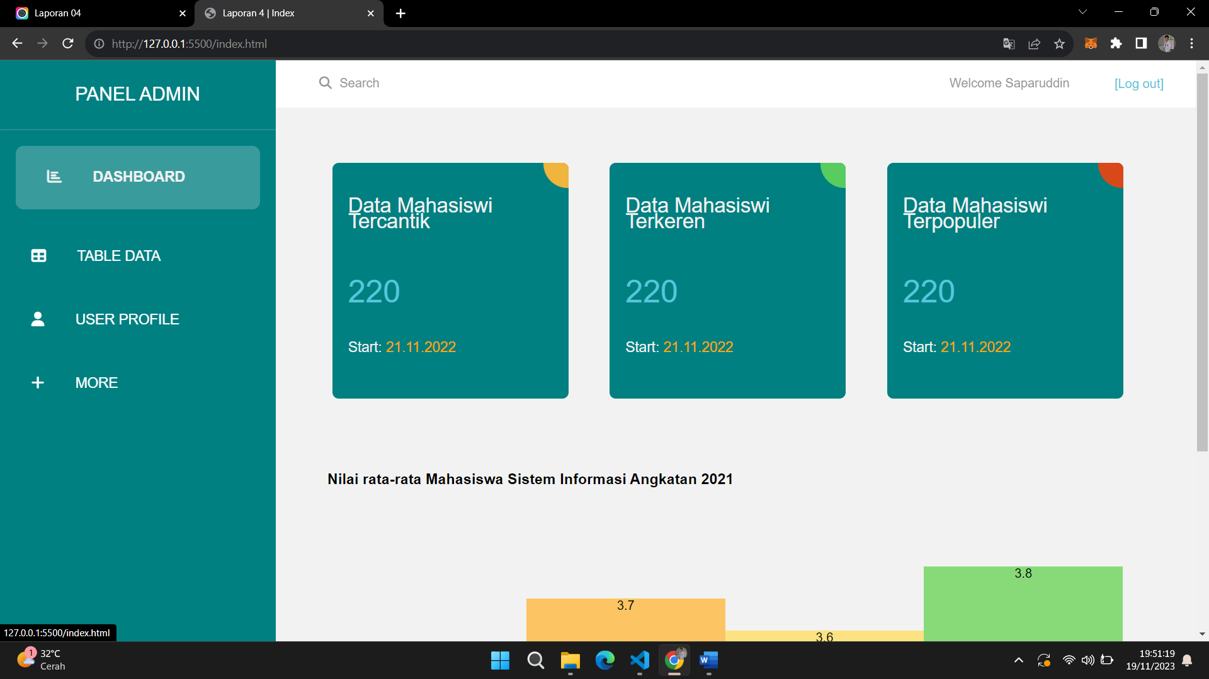

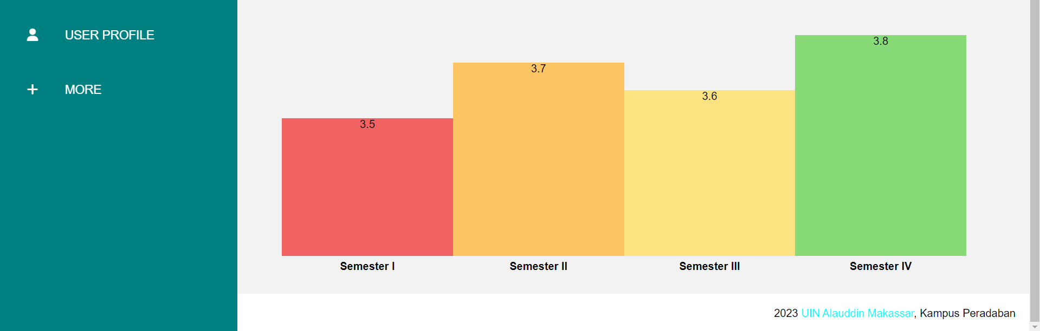

**data.html**

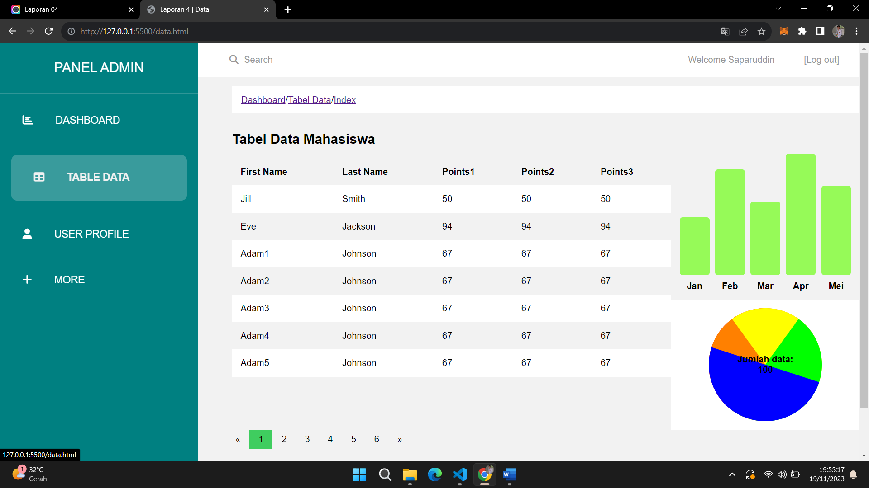



**profil.html**

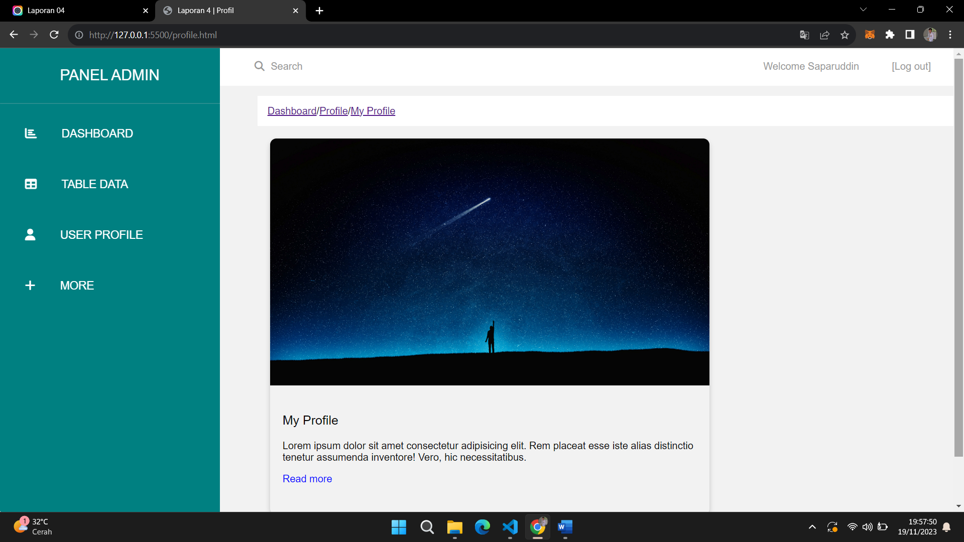



**more.html**

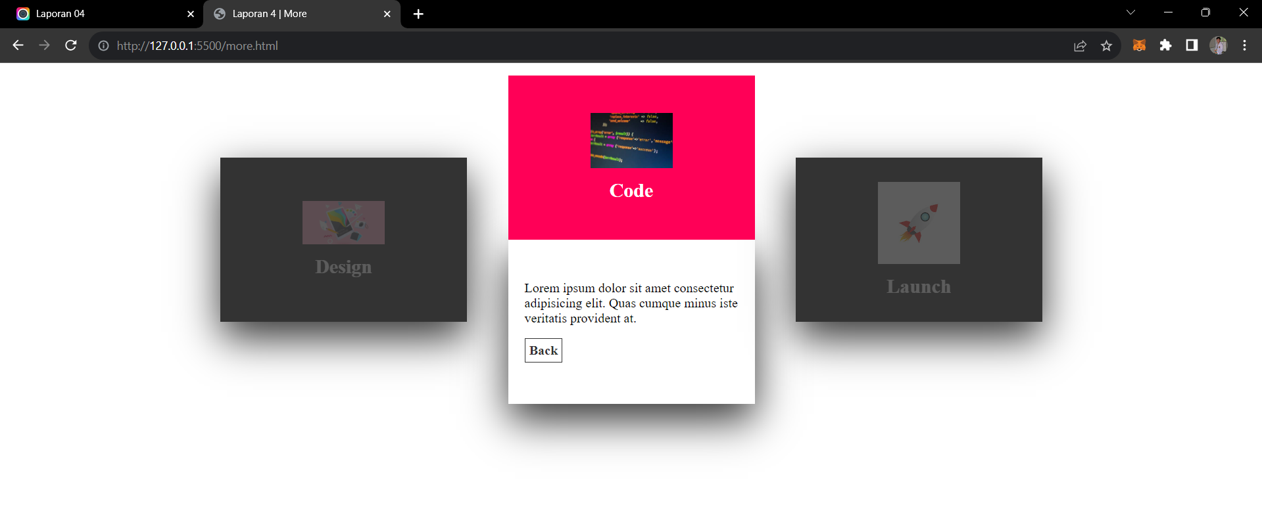

**style.css**

* {

    scroll-behavior: smooth;

    box-sizing: border-box; }

body {

    font-family: Arial, Helvetica, sans-serif;

    margin: 0;

    padding: 0;

    background-color: #f2f2f2; }

nav {

    overflow: hidden;

    background-color: white;

    margin-left: 23%;

    display: flex;

    justify-content: space-between;

    height: 60px; }

nav .nav-search {

    padding-left: 40px; }

nav .nav-search span {

    margin-right: 10px; }

nav .nav-search p {

    color: #979797; }

nav .nav-link {

    display: flex;

    justify-content: space-between;

    align-items: center; }

nav a {

    color: #55C6DB;

    padding: 26px 5px;

    text-decoration: none; }

nav p {

    float: left;

    justify-content: space-between;

    margin-right: 20px;

    margin-top: 20px;

    display: block;

    color: #979797;

    text-align: center;

    padding: 0px 16px;

    text-decoration: none; }

.nav-search p:hover {

    color: #008081;

    font-weight: bold; }

.nav-logout p:hover {

    color: #008081;

    font-weight: bold; }

ul.nav-item {

    padding: 10px 16px;

    list-style: none;

    background-color: rgba(128, 128, 128, 0.412); }

ul.nav-item li {

    display: inline;

    font-size: 18px; }

ul.nav-item li+li:before {

    padding: 8px;

    color: black;

    content: "/\00a0"; }

ul .nav-item li #now {

    color: black; }

ul.nav-item li a {

    color: #0275d8;

    text-decoration: none; }

ul.nav-item li a:hover {

    color: #01447e;

    text-decoration: underline; }

.sidenav {

    height: 100%;

    width: 350px;

    position: fixed;

    z-index: 1;

    top: 0;

    left: 0;

    background-color: #008081;

    overflow-x: hidden;

    border-radius: 0.5px 0px 0px 2px;

    text-transform: uppercase; }

.sidenav h2 {

    text-align: center;

    padding: 10px;

    font-weight: normal;

    color: white; }

.sidenav hr {

    opacity: 0.2; }

.sidenav a {

    text-indent: 5px;

    color: white;

    padding: 30px;

    text-decoration: none;

    display: block;

    font-size: 18px;

    transition: 0.3s; }

.sidenav a:hover {

    background-color: #f2f2f23c;

    color: #f1f1f1;

    font-weight: bold;

    border-radius: 10px;

    margin: 20px 20px; }

.sidenav a span {

    margin-right: 40px; }

.sidenav p {

    margin: 20px 20px;

    border-radius: 10px;

    margin-top: 25%;

    width: 87%;

    padding: 30px;

    background-color: #f2f2f23c;

    color: #f1f1f1;

    font-weight: bold;

    justify-content: center;

    align-items: center; }

.sidenav p span {

    margin-right: 40px; }

.content {

    margin-left: 27%; }

.box-hero {

    display: flex;

    justify-content: space-between;

    align-items: center;

    overflow: hidden;

    margin: 10px 0px;

    margin-right: 5rem; }

.box {

    width: 300px;

    height: 300px;

    padding: 20px;

    background-color: #008081;

    border: none;

    border-radius: 8px;

    transition: background-color 0.3s;

    margin-top: 60px; }

.box:hover {

    background-color: orange; }

.box p {

    color: #f2f2f2;

    padding: 5px 0; }

.hijau:hover {

    background-color: #3FCD5F; }

.merah {

    background-color: red; }

.merah:hover {

    background-color: red; }

#para1 {

    margin-top: 20px;

    color: #f1f1f1;

    font-size: 26px; }

#para2 {

    margin-top: 60px;

    font-size: 40px;

    color: #55C6DB; }

#para3 {

    color: orange; }

.card p {

    font-size: 17px;

    font-weight: 400;

    line-height: 20px;

    color: #666; }

.small p {

    color: #f2f2f2;

    padding: 5px 0;

    font-size: 18px; }

.go-corner {

    display: flex;

    align-items: center;

    justify-content: center;

    position: absolute;

    width: 32px;

    height: 32px;

    overflow: hidden;

    top: 0;

    right: 0;

    background-color: #F0B53D;

    border-radius: 0 4px 0 32px; }

.go-arrow {

    margin-top: -4px;

    margin-right: -4px;

    color: white;

    font-family: courier, sans; }

.card1 {

    display: block;

    position: relative;

    max-width: 262px;

    background-color: #f2f8f9;

    border-radius: 4px;

    padding: 32px 24px;

    margin: 12px;

    text-decoration: none;

    z-index: 0;

    overflow: hidden;

    width: 300px;

    height: 300px;

    padding: 20px;

    background-color: #008081;

    border: none;

    border-radius: 8px;

    transition: background-color 0.3s;

    margin-top: 60px; }

.card1:before {

    content: "";

    position: absolute;

    z-index: -1;

    top: -16px;

    right: -16px;

    background: #F0B53D;

    height: 32px;

    width: 32px;

    border-radius: 32px;

    transform: scale(1);

    transform-origin: 50% 50%;

    transition: transform 0.25s ease-out; }

.card1:hover:before {

    transform: scale(25); }

.card1:hover p {

    transition: all 0.3s ease-out;

    color: rgba(255, 255, 255, 0.8); }

.card1:hover h3 {

    transition: all 0.3s ease-out;

    color: #fff; }

.go-corner2 {

    display: flex;

    align-items: center;

    justify-content: center;

    position: absolute;

    width: 32px;

    height: 32px;

    overflow: hidden;

    top: 0;

    right: 0;

    background-color: #59CC60;

    border-radius: 0 4px 0 32px; }

.card2 {

    display: block;

    position: relative;

    max-width: 262px;

    background-color: #f2f8f9;

    border-radius: 4px;

    padding: 32px 24px;

    margin: 12px;

    text-decoration: none;

    z-index: 0;

    overflow: hidden;

    width: 300px;

    height: 300px;

    padding: 20px;

    background-color: #008081;

    border: none;

    border-radius: 8px;

    transition: background-color 0.3s;

    margin-top: 60px; }

.card2:before {

    content: "";

    position: absolute;

    z-index: -1;

    top: -16px;

    right: -16px;

    background: #3FCD5F;

    height: 32px;

    width: 32px;

    border-radius: 32px;

    transform: scale(1);

    transform-origin: 50% 50%;

    transition: transform 0.25s ease-out; }

.card2:hover:before {

    transform: scale(25); }

.card2:hover p {

    transition: all 0.3s ease-out;

    color: rgba(255, 255, 255, 0.8); }

.card2:hover h3 {

    transition: all 0.3s ease-out;

    color: #fff; }

.go-corner3 {

    display: flex;

    align-items: center;

    justify-content: center;

    position: absolute;

    width: 32px;

    height: 32px;

    overflow: hidden;

    top: 0;

    right: 0;

    background-color: #D74918;

    border-radius: 0 4px 0 32px; }

.card3 {

    display: block;

    position: relative;

    max-width: 262px;

    background-color: #f2f8f9;

    border-radius: 4px;

    padding: 32px 24px;

    margin: 12px;

    text-decoration: none;

    z-index: 0;

    overflow: hidden;

    width: 300px;

    height: 300px;

    padding: 20px;

    background-color: #008081;

    border: none;

    border-radius: 8px;

    transition: background-color 0.3s;

    margin-top: 60px; }

.card3:before {

    content: "";

    position: absolute;

    z-index: -1;

    top: -16px;

    right: -16px;

    background: #D74918;

    height: 32px;

    width: 32px;

    border-radius: 32px;

    transform: scale(1);

    transform-origin: 50% 50%;

    transition: transform 0.25s ease-out; }

.card3:hover:before {

    transform: scale(25); }

.card3:hover p {

    transition: all 0.3s ease-out;

    color: rgba(255, 255, 255, 0.8); }

.card3:hover h3 {

    transition: all 0.3s ease-out;

    color: #fff; }

.data {

    margin-left: 26rem;

    margin-right: 5.8rem;

    margin-top: 5rem;

    margin-bottom: 2rem; }

tr:hover {

    background-color: coral; }

.tabel-data {

    display: flex;

    width: 100%; }

.data-satu {

    width: 70%; }

.data-dua {

    width: 30%; }

.donut-chart {

    position: relative;

    width: 200px;

    height: 200px;

    margin: auto;

    border-radius: 50%; }

.donut-chart__slice {

    position: absolute;

    width: 100%;

    height: 100%;

    clip: rect(0, 100px, 200px, 0);

    border-radius: 50%; }

.donut-chart__slice--1 {

    transform: rotate(0deg);

    background-color: #ff0000; }

.donut-chart__slice--2 {

    transform: rotate(72deg);

    background-color: #ff8000; }

.donut-chart__slice--3 {

    transform: rotate(144deg);

    background-color: #ffff00; }

.donut-chart__slice--4 {

    transform: rotate(216deg);

    background-color: #00ff00; }

.donut-chart__slice--5 {

    transform: rotate(288deg);

    background-color: #0000ff; }

.donut-chart__label {

    position: absolute;

    top: 50%;

    left: 50%;

    transform: translate(-50%, -50%);

    font-size: 16px;

    font-weight: bold;

    text-align: center; }

.diagram {

    display: grid;

    grid-template-columns: repeat(5, 1fr);

    grid-template-rows: repeat(10, 1fr);

    grid-gap: 10px;

    height: 300px;

    margin: auto; }

.card-profil {

    /* Tambahkan bayangan untuk membuat efek "card" */

    box-shadow: 0 4px 8px 0 rgba(0, 0, 0, 0.2);

    transition: 0.3s;

    width: 700px;

    height: 600px;

    margin: 20px;

    border-radius: 10px;

    overflow: hidden;

    /* Sudut membulat */ }

.card-profil:hover {

    /* Saat mengarahkan mouse, tambahkan bayangan yang lebih dalam */

    box-shadow: 0 8px 16px 0 rgba(0, 0, 0, 0.2); }

.card-image {

    /* Tambahkan gambar di bagian atas card */

    width: 100%;

    transition: 0.5s all ease-out;

    border-radius: 10px 10px 0 0;

    /* Sudut membulat di bagian atas gambar */ }

.card-image:hover {

    /* Saat mengarahkan mouse, zoom gambar */

    transform: scale(1.1); }

.card-content {

    /* Tambahkan konten di bagian bawah card */

    padding: 20px; }

.card-title {

    /* Tambahkan judul dengan font tebal */

    font-weight: lighter;

    font-size: 20px; }

.card-description {

    /* Tambahkan deskripsi dengan font normal */

    font-weight: normal;

    font-size: 16px; }

.card-link {

    /* Tambahkan link "read more" dengan warna biru */

    color: blue;

    text-decoration: none;

    font-size: 16px; }

.card-link:hover {

    /* Saat mengarahkan mouse, ubah warna link menjadi lebih gelap */

    color: darkblue; }

.footer {

    background-color: #fff;

    color: #000;

    font-family: Arial, sans-serif;

    padding: 20px;

    display: flex;

    align-items: center;

    justify-content: flex-end; }

.footer p {

    margin: 0; }

.balok {

    background-color: rgba(98, 255, 0, 0.636);

    border-radius: 5px;

    display: flex;

    align-items: end;

    justify-content: center;

    color: white; }

.label {

    grid-row: 11 / 12;

    display: flex;

    align-items: center;

    justify-content: center;

    font-weight: bold; }

.pagination {

    display: inline-block;

    margin-left: 25rem; }

.pagination #aktif {

    background-color: #3FCD5F; }

.pagination a {

    color: black;

    float: left;

    padding: 8px 16px;

    text-decoration: none; }

div.desc {

    margin-top: 10px;

    padding: 15px;

    text-align: left; }

.desc a {

    color: #0275d8;

    text-decoration: none; }

.clearfix:after {

    content: "";

    display: table;

    clear: both; }

.path {

    margin-top: 1rem;

    height: 3rem;

    align-items: center;

    padding: 1rem;

    display: flex;

    width: 100%;

    background-color: #fff; }

table {

    border-collapse: collapse;

    width: 100%; }

th,

td {

    text-align: left;

    padding: 15px; }

tr:nth-child(even) {

    background-color: #fff; }

**index.html**

<!DOCTYPE html>

<html lang="en">

<head>

  <meta charset="UTF-8" />

  <meta name="viewport" content="width=device-width, initial-scale=1.0" />

  <title>Laporan 4</title>

  <link rel="stylesheet" href="assets/css/style.css" />

  <link rel="stylesheet" href="https://cdnjs.cloudflare.com/ajax/libs/font-awesome/6.4.2/css/all.min.css" />

  <link rel="stylesheet" href="https://unpkg.com/charts.css/dist/charts.min.css">

</head>

<body>

  <header>

    <nav>

      <div class="nav-search">

        <p>

          <span class="fa-solid fa-magnifying-glass" style="color: #979797"></span>Search

        </p>

      </div>

      <div class="nav-logout">

        <p><span></span>Welcome Saparuddin</p>

        <p><span></span><a href="login.html">[Log out]</a></p>

      </div>

    </nav>

  </header>

  <div class="sidenav">

    <h2>Panel Admin</h2>

    <hr />

    <a href="index.html"><span class="fa fa-chart-bar"></span>Dashboard</a>

    <a href="data.html"><span class="fa fa-table"></span>Table Data</a>

    <a href="profile.html"><span class="fa fa-user"></span>User Profile</a>

    <a href="more.html"><span class="fa fa-plus"></span>More</a>

  </div>

  <section class="content">

    <div class="box-hero">

      <div class="card">

        <a class="card1" href="#">

          <div class="small">

            <p id="para1">Data Mahasiswi Tercantik</p>

            <p id="para2">220</p>

            <p>Start: <span id="para3">21.11.2022</span></p>

          </div>

          <div class="go-corner" href="#">

            <div class="go-arrow"></div>

          </div>

        </a>

      </div>

      <div class="card">

        <a class="card2" href="#">

          <div class="small">

            <p id="para1">Data Mahasiswi Terkeren</p>

            <p id="para2">220</p>

            <p>Start: <span id="para3">21.11.2022</span></p>

          </div>

          <div class="go-corner2" href="#">

            <div class="go-arrow"></div>

          </div>

        </a>

      </div>

      <div class="card">

        <a class="card3" href="#">

          <div class="small">

            <p id="para1">Data Mahasiswi Terpopuler</p>

            <p id="para2">220</p>

            <p>Start: <span id="para3">21.11.2022</span></p>

          </div>

          <div class="go-corner3" href="#">

            <div class="go-arrow"></div>

          </div>

        </a>

      </div>

    </div>

  </section>

  <div class="data">

    <table class="charts-css column hide-data show-labels">

      <h3> Nilai rata-rata Mahasiswa Sistem Informasi Angkatan 2021 </h3>

      <tbody>

        <tr>

          <th scope="row"> Semester I </th>

          <td style="--size: 0.5;"> 3.5 </td>

        </tr>

        <tr>

          <th scope="row"> Semester II </th>

          <td style="--size: 0.7;"> 3.7 </td>

        </tr>

        <tr>

          <th scope="row"> Semester III </th>

          <td style="--size: 0.6;"> 3.6 </td>

        </tr>

        <tr>

          <th scope="row"> Semester IV </th>

          <td style="--size: 0.8;"> 3.8 </td>

        </tr>

      </tbody>

    </table>

  </div>

  <div class="footer">

    <p>2023 <span style="color: cyan;">UIN Alauddin Makassar</span>, Kampus Peradaban</p>

  </div>

</body>

</html>

**data.html**

<!DOCTYPE html>

<html lang="en">

<head>

  <meta charset="UTF-8" />

  <meta name="viewport" content="width=device-width, initial-scale=1.0" />

  <title>Laporan 4</title>

  <link rel="stylesheet" href="assets/css/style.css" />

  <link rel="stylesheet" href="https://cdnjs.cloudflare.com/ajax/libs/font-awesome/6.4.2/css/all.min.css" />

</head>

<body>

  <header>

    <nav>

      <div class="nav-search">

        <p>

          <span class="fa-solid fa-magnifying-glass" style="color: #979797"></span>Search

        </p>

      </div>

      <div class="nav-logout">

        <p><span></span>Welcome Saparuddin</p>

        <p><span></span>[Log out]</p>

      </div>

    </nav>

  </header>

  <div class="sidenav">

    <h2>Panel Admin</h2>

    <hr />

    <a href="index.html"><span class="fa fa-chart-bar"></span>Dashboard</a>

    <a href="data.html"><span class="fa fa-table"></span>Table Data</a>

    <a href="profile.html"><span class="fa fa-user"></span>User Profile</a>

    <a href="more.html"><span class="fa fa-plus"></span>More</a>

  </div>

  <section class="content">

    <div class="navbar-content">

      <div class="path">

        <a href="">Dashboard</a>

        <span>/</span>

        <a href="">Tabel Data</a>

        <span>/</span>

        <a href="">Index</a>

      </div>

      <div class="tabel-data">

        <div class="data-satu">

          <h1 style="margin-top: 2rem">Tabel Data Mahasiswa</h1>

          <table>

            <tr>

              <th>First Name</th>

              <th>Last Name</th>

              <th>Points1</th>

              <th>Points2</th>

              <th>Points3</th>

            </tr>

            <tr>

              <td>Jill</td>

              <td>Smith</td>

              <td>50</td>

              <td>50</td>

              <td>50</td>

            </tr>

            <tr>

              <td>Eve</td>

              <td>Jackson</td>

              <td>94</td>

              <td>94</td>

              <td>94</td>

            </tr>

            <tr>

              <td>Adam</td>

              <td>Johnson</td>

              <td>67</td>

              <td>67</td>

              <td>67</td>

            </tr>

          </table>

        </div>

        <div class="data-dua">

          <table>

            <tr>

              <td>

                <div class="diagram">

                  <div class="balok" style="grid-row: 7 / 11;"></div>

                  <div class="balok" style="grid-row: 4 / 11;"></div>

                  <div class="balok" style="grid-row: 6 / 11;"></div>

                  <div class="balok" style="grid-row: 3 / 11;"></div>

                  <div class="balok" style="grid-row: 5 / 11;"></div>

                  <div class="label">Jan</div>

                  <div class="label">Feb</div>

                  <div class="label">Mar</div>

                  <div class="label">Apr</div>

                  <div class="label">Mei</div>

                </div>

              </td>

            </tr>

            <tr>

              <td>

                <div class="donut-chart">

                  <div class="donut-chart__slice donut-chart__slice--1"></div>

                  <div class="donut-chart__slice donut-chart__slice--2"></div>

                  <div class="donut-chart__slice donut-chart__slice--3"></div>

                  <div class="donut-chart__slice donut-chart__slice--4"></div>

                  <div class="donut-chart__slice donut-chart__slice--5"></div>

                  <div class="donut-chart__label">Jumlah data: 100</div>

                </div>

              </td>

            </tr>

          </table>

        </div>

      </div>

    </div>

  </section>

  <div class="pagination" style="margin-bottom: 3rem;">

    <a href="#">&laquo;</a>

    <a id="aktif" href="#">1</a>

    <a href="#">2</a>

    <a href="#">3</a>

    <a href="#">4</a>

    <a href="#">5</a>

    <a href="#">6</a>

    <a href="#">&raquo;</a>

  </div>

  <div class="footer">

    <p>2023 <span style="color: cyan;">UIN Alauddin Makassar</span>, Kampus Peradaban</p>

  </div>

</body>

</html>

**more.html**

<!DOCTYPE html>

<html lang="en">

<head>

    <meta charset="UTF-8">

    <meta http-equiv="X-UA-Compatible" content="IE=edge">

    <meta name="viewport" content="width=device-width, initial-scale=1.0">

    <title>More</title>

    <style>

        body {

            margin: auto; }

        .container {

            width: 1000px;

            position: relative;

            display: flex;

            justify-content: space-between;

            margin: 15px auto; }

        .container .card {

            position: relative;

            cursor: pointer; }

        .container .card .face {

            width: 300px;

            height: 200px;

            transition: 0.5s; }

        .container .card .face.face1 {

            position: relative;

            background: #333;

            display: flex;

            justify-content: center;

            align-items: center;

            z-index: 1;

            transform: translateY(100px); }

        .container .card:hover .face.face1 {

            background: #ff0057;

            transform: translateY(0); }

        .container .card .face.face2 {

            position: relative;

            background: #fff;

            display: flex;

            justify-content: center;

            align-items: center;

            padding: 20px;

            box-sizing: border-box;

            box-shadow: 0 20px 50px rgba(0, 0, 0, 0.8);

            transform: translateY(-100px); }

        .container .card:hover .face.face2 {

            transform: translateY(0); }

        .container .card .face.face2 .content p {

            margin: 0;

            padding: 0; }

        .container .card .face.face1 .content {

            opacity: 0.2;

            transition: 0.5s; }

        .container .card:hover .face.face1 .content {

            opacity: 1; }

        .container .card .face.face1 .content img {

            max-width: 100px; }

        .container .card .face.face1 .content h3 {

            margin: 10px 0 0;

            padding: 0;

            color: #fff;

            text-align: center;

            font-size: 1.5em; }

        .container .card .face.face2 .content a {

            margin: 15px 0 0;

            display: inline-block;

            text-decoration: none;

            font-weight: 900;

            color: #333;

            padding: 5px;

            border: 1px solid #333; }

        .container .card .face.face2 .content a:hover {

            background: #333;

            color: #fff; }

    </style>

</head>

<body>

    <div class="container">

        <div class="card">

            <div class="face face1">

                <div class="content">

                    <img

                        src="https://www.gamelab.id/uploads/modules/CHANGELOG/10%20Jenis%20Desain%20Populer%20-%20GAMELAB.ID%20(3).jpg?1684831152244">

                    <h3>Design</h3>

                </div>

            </div>

            <div class="face face2">

                <div class="content">

                    <p>Lorem ipsum dolor sit amet consectetur adipisicing elit. Quascumque minus iste veritatis

                        provident at.</p>

                    <a href="index.html">Back</a>

                </div>

            </div>

        </div>

        <div class="card">

            <div class="face face1">

                <div class="content">

                    <img src="https://encrypted-tbn0.gstatic.com/images?q=tbn:ANd9GcTrfDsXF0sZVjPps4eCPw2fAoMMVUipS9SHbw&usqp=CAU"

                        alt="">

                    <h3>Code</h3>

                </div>

            </div>

            <div class="face face2">

                <div class="content">

                    <p>Lorem ipsum dolor sit amet consectetur adipisicing elit. Quas cumque minus iste veritatis

                        provident at.</p>

                    <a href="index.html">Back</a>

                </div>

            </div>

        </div>

        <div class="card">

            <div class="face face1">

                <div class="content">

                    <img

                        src="https://encrypted-tbn0.gstatic.com/images?q=tbn:ANd9GcRO0zTeBbbBpsVowMlvd4h1TEYgu3fr-To4MA&usqp=CAU">

                    <h3>Launch</h3>

                </div>

            </div>

            <div class="face face2">

                <div class="content">

                    <p>Lorem ipsum dolor sit amet consectetur adipisicing elit. Quas cumque minus iste veritatis

                        provident at.</p>

                    <a href="index.html">Back</a>

                </div>

            </div>

        </div>

    </div>

</body>

</html>

**profile.html**

<!DOCTYPE html>

<html lang="en">

<head>

  <meta charset="UTF-8" />

  <meta name="viewport" content="width=device-width, initial-scale=1.0" />

  <title>Laporan 4</title>

  <link rel="stylesheet" href="assets/css/style.css" />

  <link rel="stylesheet" href="https://cdnjs.cloudflare.com/ajax/libs/font-awesome/6.4.2/css/all.min.css" />

</head>

<body>

  <header>

    <nav>

      <div class="nav-search">

        <p>

          <span class="fa-solid fa-magnifying-glass" style="color: #979797"></span>Search

        </p>

      </div>

      <div class="nav-logout">

        <p><span></span>Welcome Saparuddin</p>

        <p><span></span>[Log out]</p>

      </div>

    </nav>

  </header>

  <div class="sidenav">

    <h2>Panel Admin</h2>

    <hr />

    <a href="data.html"><span class="fa fa-chart-bar"></span>Dashboard</a>

    <a href="index.html"><span class="fa fa-table"></span>Table Data</a>

    <a href="profile.html"><span class="fa fa-user"></span>User Profile</a>

    <a href="more.html"><span class="fa fa-plus"></span>More</a>

  </div>

  <section class="content">

    <div class="path">

      <a href="">Dashboard</a>

      <span>/</span>

      <a href="">Profile</a>

      <span>/</span>

      <a href="">My Profile</a>

    </div>

    <div class="card-profil">

      <img src="night-man.jpg" alt="Gambar" class="card-image">

      <div class="card-content">

        <h3 class="card-title">My Profile</h3>

        <p class="card-description">Lorem ipsum dolor sit amet consectetur adipisicing elit. Rem placeat esse iste alias distinctio tenetur assumenda inventore! Vero, hic necessitatibus.</p>

        <a href="#" class="card-link">Read more</a>

      </div>

    </div>

  </section>

  <div class="footer">

    <p>2023 <span style="color: cyan;">UIN Alauddin Makassar</span>, Kampus Peradaban</p>

  </div>

</body>

</html>